
Physics Lab
Department of MPS

Course Name : Engineering Physics -1

Course Code : PHY 109 LAB

Section No :

Group No :

Experiment No :

Name of the Experiment:

Date of Allocation :

Date of Submission:

Submitted To :

Student’s ID :

Student’s Name :

Physics Lab
PHY-109 LAB
Experiment No: 05
Name of the Experiment:
Measurement of DC and AC voltages and determination of line frequency using an oscilloscope and a function generator.

Theory:

Frequency can be easily measured with an oscilloscope. The unknown frequency (line frequency) is applied to the vertical input while the reference frequency (signal generator) is applied to the horizontal input. When two harmonic vibrations, mutually perpendicular to each other, are superposed on one another, the resultant curve or pattern may take any number of shapes depending upon the phase difference of the vibrations. These curves are called Lissajous figures. Some typical patterns are shown in Figure-14.

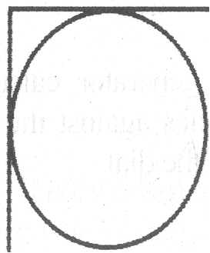 | 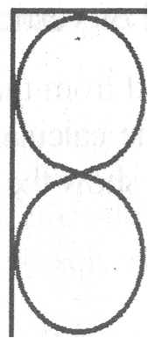 | 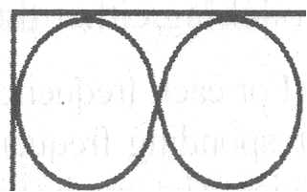
(a) (b) (c)
Figure -14: Lissajous figure

The frequency ratio of the two superposed vibrations can be calculated from the relation
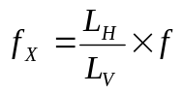
f_{X} = unknown frequency f = known frequency
L_{H} = number of loops which touch the horizontal tangent line
L_{V} = number of loops which touch the vertical tangent line

Signal of different frequencies can be obtained from a signal generator and can be supplied to the horizontal input of the oscilloscope. The superposition of these signals with the unknown signal (line signal), which is applied to the vertical input of the oscilloscope, will give rise to curves of given shapes. From these curves, the frequency of the line signal can be calculated in the manner described above.

Apparatus:

Oscilloscope, function generator, transformer, battery, multimeter, etc.

Procedure:

- Switch on the oscilloscope and obtain a bright spot at the centre of the oscilloscope screen by adjusting the focus control and the horizontal and vertical switches respectively.

- Fix the horizontal frequency selector at the line sweep. Fix the vertical input at some suitable position of the selector control.

- Switch on the signal generator and apply a signal to the oscilloscope and go on adjusting the horizontal and vertical gain switches and the frequency of the signal from the generator until a single loop is obtained on the screen as shown in Figure- 14 (a). Record the corresponding frequency of the signal.

- It is a good practice to have the loop rotating slowly rather than being stationary. This eliminates the possibilities of an error in counting tangent points. If the pattern is stationary a double image may be formed. In such cases the end of the trace should be counted as one half a tangent points, rather than a full point. This condition may occur when neither frequency can be varied.

- Keeping everything else fixed, go on changing the frequency of the signal generator until two loops are obtained, first touching the horizontal line and then the vel1ical line.

- Record the corresponding frequencies. In this way record the frequencies of the signals which produce a number of loops touching either the horizontal or vertical lines.

- For each frequency as recorded from the dial of the generator, calculate the line frequency.

DATA SHEET: Measurement of DC and AC voltages and determination of line frequency using an oscilloscope and a function generator.

Table -1: Determining DC voltage:
No. of  Obs. | Volts per Division  A  Volts | Number of Divisions Deflected  B | EMF of the Battery  A×B  Volts | Mean  EMF  Volts
1
2
3

Table -2: Determining AC voltage:
No. of  Obs. | Volts per Division  A  Volts | Number of Divisions from top to bottom  B | Peak to Peak Voltage of the signal  A×B  Volts | Mean  Peak to Peak  Voltage, V_{p-p}  Volts
1
2
3

Table -3: Determining line Frequency:
No. of  Obs. | Sweep time per Division  A  ms | Number of Divisions for one wave length  B | Time period  T  A×B  ms | Frequency of the signal  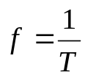  Hz | Mean Frequency  Hz
1
2
3

Table -4: Determining line Frequency ( f_{x} ) by Lissajous figure:
No. of  Obs. | Known frequency from function generator  f  Hz | Number of vertical loops  L_{V} | Number of horizontal loops  L_{H} | Line frequency  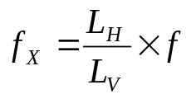Hz | Mean Frequency  Hz
1
2
3
4
Calculation:

Experimental value of DC voltage (measured by oscilloscope experiment) =…………

Standard value of DC voltage (measured by multimeter) = …………….

Percentage difference = …………….

Experimental value of AC voltage (measured by oscilloscope experiment), V_{p-p} =……………..

AC voltage measured by multimeter, V_{rms} =
Standard value of AC voltage (measured by multimeter),

Percentage difference = …………….

Experimental value of AC frequency (measured by Lissajous figure) =……………..

Standard value of AC frequency = ……50…Hz……. (Known)

Percentage difference = …………….

Results:

- DC voltage =

- AC voltage =

- Line frequency (measured by Time/Div knob) =

- Line frequency (measured by Lissajous figure) =

Discussions:

- As mentioned in the procedure, it is better to have the Lissajous pattern slowly rotating.

- It is difficult to record the number of both the horizontal and vertical loops at the same time. It is better to fix the number of either vertical or horizontal loops constant and then vary the number or the other and note the corresponding frequency of the signal from the signal generator.

Pre-Lab Exercise:

- An electric fan rotates 360 cycles per minute. What are its time period and frequency?

...........................................................................................................................................................

...........................................................................................................................................................

...........................................................................................................................................................

...........................................................................................................................................................

- What are the peak to peak voltage and frequency of the sine wave shown below?
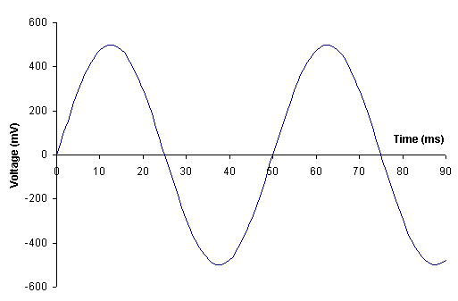
...........................................................................................................................................................

...........................................................................................................................................................

...........................................................................................................................................................

...........................................................................................................................................................

- What are the peak to peak voltage and frequency of the square wave shown below?
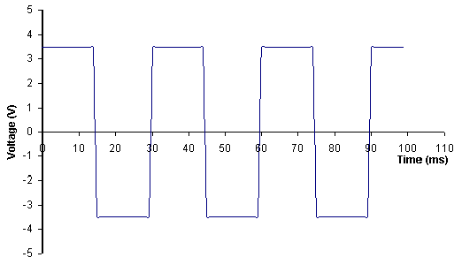
.....................................................................................................................................................................

.....................................................................................................................................................................

.....................................................................................................................................................................

.....................................................................................................................................................................

- What are the peak to peak voltage and frequency of the triangle wave shown below?

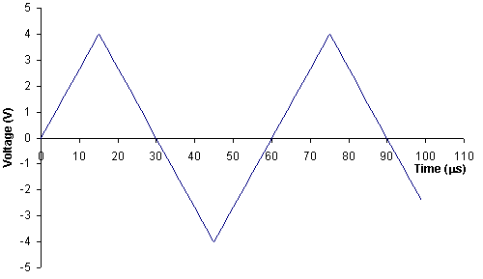
.....................................................................................................................................................................

.....................................................................................................................................................................

.....................................................................................................................................................................

Sample oral Questions and Answers

- What are oscilloscope and function generator(signal generator)?

Ans: An oscilloscope (abbreviated sometimes as scope or O-scope) is a type of electronic test instrument that allows signal voltages to be viewed, usually as a two-dimensional graph of one or more electrical potential differences (vertical axis) plotted as a function of time or of some other voltage (horizontal axis).

A function generator is a piece of electronic test equipment or software used to generate electrical waveforms

- What are frequency, time period, wavelength, speed of wave?

Ans: Frequency is defined as a number of cycles per unit time. In SI units, the unit of frequency is hertz (Hz), named after the German physicist Heinrich Hertz. For example, 1 Hz means that an event repeats once per second. Time Period(T) is the duration of one cycle in a repeating event, so the period is the reciprocal of the frequency.

Wavelength(λ) of a sinusoidal wave is the spatial period of the wave – the distance over which the wave's shape repeats. It is usually determined by considering the distance between consecutive corresponding points of the same phase, such as crests, troughs, or zero crossings. | 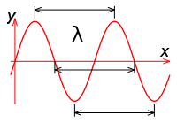
Speed(v) is the distance traveled by a given point on the wave (such as a crest) in a given interval of time (Time Period). | 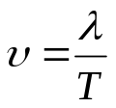
- What is power frequency (line frequency)?
Ans : The utility frequency, (power) line frequency (American English) or mains frequency (British English) is the frequency at which alternating current (AC) is transmitted from a power plant to the end user. In most parts of the world this is 50 Hz, although in the America it is typically 60 Hz.
- What are A.C. and D.C. currents?
Ans: In alternating current (AC, also ac) the movement (or flow) of electric charge periodically reverses direction. An electric charge would for instance move forward, then backward, then forward, then backward, over and over again.  In direct current (DC), the movement (or flow) of electric charge is only in one direction. | 